LAPORAN RESMI

PRAKTIKUM PEMROGRAMAN BERORIENTASI OBJEK

ADVANCE CLASS DIAGRAM 1



Fadilah Fahrul Hardiansyah S.ST., M. Kom

Ratri Maria Manik

3121600039

D4 TEKNIK INFORMATIKA – B

PROGRAM STUDI TEKNIK INFORMATIKA

POLITEKNIK ELEKTRONIKA NEGERI SURABAYA

TA 2022/2023

**LATIHAN**

Implementasikan class diagram berikut dalam kode program!

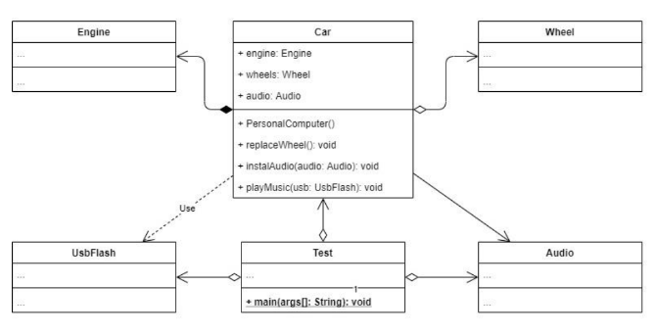

|  |
| --- |
| public class Engine{  } |

|  |
| --- |
| public class Wheel{  } |

|  |
| --- |
| public class UsbFlash{  } |

|  |
| --- |
| public class Audio{  } |

|  |
| --- |
| public class Car{  public Engine engine;  public Wheel wheel;  public Audio audio;  public Car(){  this.engine = new Engine();  }  public void replaceWheel(){  this.wheel = new Wheel();  }    public void instalAudio(Audio audio){  this.audio = Audio();  }  public void playMusic(usbFlash usb){  }  } |

**TUGAS**

Mengamati kode program dan membuat class diagram

|  |
| --- |
| public class Avatar {  }  public class Skill {  }  public class Quest {  }  public class Weapon {  }  public class Player {  public Avatar avatar;  public Skill skill;  public Quest quest;  public Player(){  this.avatar = new Avatar();  }  public void learnSkill(){  this.skill = new Skill();  }    public void takeQuest(Quest quest){  this.quest = quest;  }  public void attack(Weapon weapon){  //attack with weapon;  }  } |

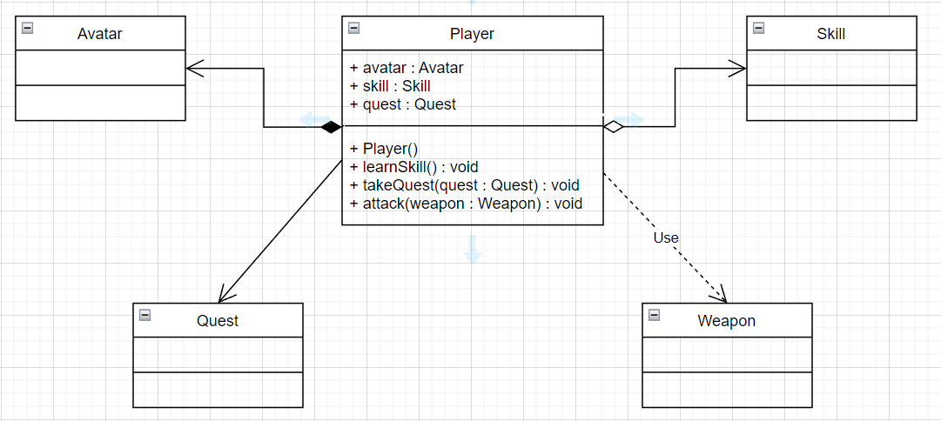

Relasi dari UML class diagram diatas :

1. Player kepada Avatar berelasi sebagai composition
2. Player kepada Skill berelasi sebagai aggregation
3. Player kepada Quest berelasi sebagai association
4. Player kepada Weapon berelasi sebagai dependency